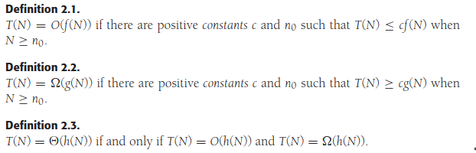
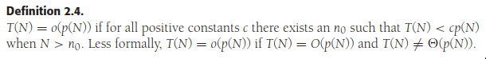
Sometimes a growth function is bigger at certain points than others
ie, say g(N) < f(N) for 1 < N < 100, but for N > 100, f(N) < g(N);
1000N > N^2 for small values of N, but N^2 < 1000N as lim → inf.
Instead, compare the relative rates of growth.

ex. 1000N and N²
From def 2.1, there is some point n0 past which c * f(N) is always at least as large as T(N).
If constant factors are ignored, then f(N) is at least as big as T(N).
T(N) = 1000N; f(N) = N²
n₀ = 1000; c = 1
Could also use n0 = 10; c = 100
Thus, 1000N = O(N^2) ↔ T(N) ≤ f(N) by def 2.1
“1000N is Big-Oh N^2” ↔ “1000N has growth rate that is less than or equal to that of f(N)”

By def 2.1,
T(N) = O(f(N) ↔ T(N) ≤ f(N)
T(N) grows at a rate no faster than f(N)
f(N) is an upper bound on T(N) → f(N) = Omega(T(N)) ↔ T(N) is a lower bound on f(N)
ie. N³ grows faster than N², so
N² = O(N^3) ↔ N³ = Omega(N^2)
ie. f(N) = N² and g(N) = 2N² have the same growth rate, so
N² = O(2N2) and N² = Omega(2N^2)
f(N) = O(g(N)) and f(N) = Omega(g(N))

By def 2.2,
T(N) = Omega(g(N)) ↔ T(N) ≥ g(N)
“T(N) has growth rate that is greater than or equal to g(N)”

By def 2.3,
T(N) = Theta(h(N))
“T(N) has growth rate that equals growth rate of h(N)”

By def 2.4,
T(N) = o(p(N)) ↔ T(N) < h(N)
“T(N) is Little-Oh p(N)” ↔ “T(N) has growth rate that is less than that of h(N)”

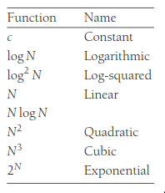

Rule 1.
If T1(N) = O(f(N)) and T2(N) = O(g(N)), then
a. T₁(N) + T₂(N) = O(f(N) + g(N))
b. T₁(N) * T₂(N) = O(f(N) * g(N))

Rule 2.
If T(N) is a polynomial, degree k, then T(N) = Theta(N^{k})

Rule 3. log^{k} N = O(N) for any constant k
(logs grow very slowly)

Etiquette
Don’t include constants or low ordered terms inside Big-Oh!
ie. Do not: T(N) = O(2N²)
Do not: T(N) = O(N² + N)
DO: T(N) = O(N²)

Determine relative growth rates of f(N) and g(N) by computing lim_{N→ inf}f(N)/g(N)
Four possible outcomes:
1. lim = 0 → f(N) = o(g(N))
2. c =/= 0 → f(N) = Theta(g(N))
3. lim = inf → g(N) = o(f(N))
4. lim DNE → No relation [rare]
Normally, you don’t need to worry about this.

Analysis
Analyze the runtime.
Factors to consider:
- compiler and computer used
- algorithm used
- input of algorithm

Define two functions T_{avg}(N) and T_{worst}(N): average and worst-case running time w/ algorithm of input size N
T_{avg}(N) ≤ T_{worst}(N)
Best case isn’t often analyzed b/c it doesn’t represent typical behavior
T_{avg} is typical
T_{worst} is a guarantee for performance and input
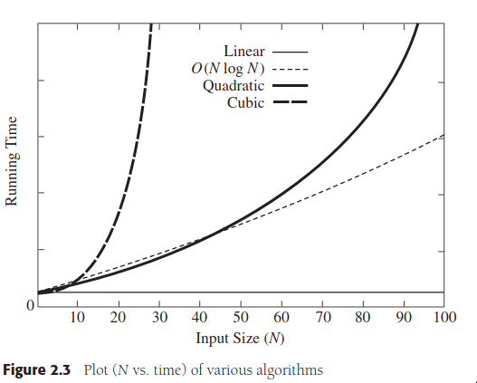
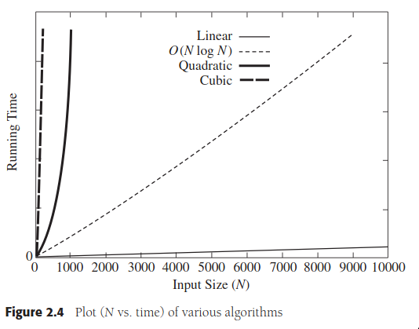

Runtime Calculations
Create more efficient algorithms. Low runtime, more efficient.
Conventions of analysis for generalization: no particular unites of time (throw out leading constants); no low-order terms; compute Big-Oh running time; Big-Oh is upper bound, so program may stop earlier than this.

Example.
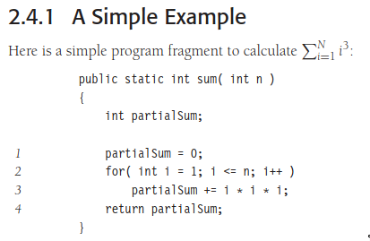

Declaration of variable: no time
Lines 1-4: one unit each
Line 2: testing i ≤ N; N+1 for all tests; N for all increments. Total: 2N+2
Line 3: four units per time executed (two multiplication; one addition; one assignment) executed N times. Total: 4N
Ignore calling method and returning.
Total: 6N+4, simplified to O(N).

General Rules
1. for loop
at most the running time of the statements inside the for loop including tests, times the number of iterations
2. Nested loops
Analyze from inside out
Total runtime inside group of nested loops is :
the runtime of the statement multiplied by the product of the sizes of all the loops
3. Consecutive Statements
add these.
eg, O(N) followed by O(N²) is a total of O(N²)
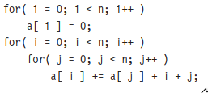

4. if/else
never more than the running time of the test plus the larger of the running times of S1 and S2
analyze from the inside
if there are recursive methods…
if recursion is thin for loop, trivial
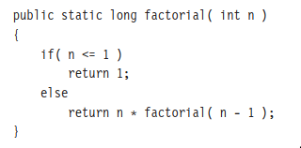

O(N)

